DOKUMENTASI

TC001-STEP 1: Input Nama Lengkap

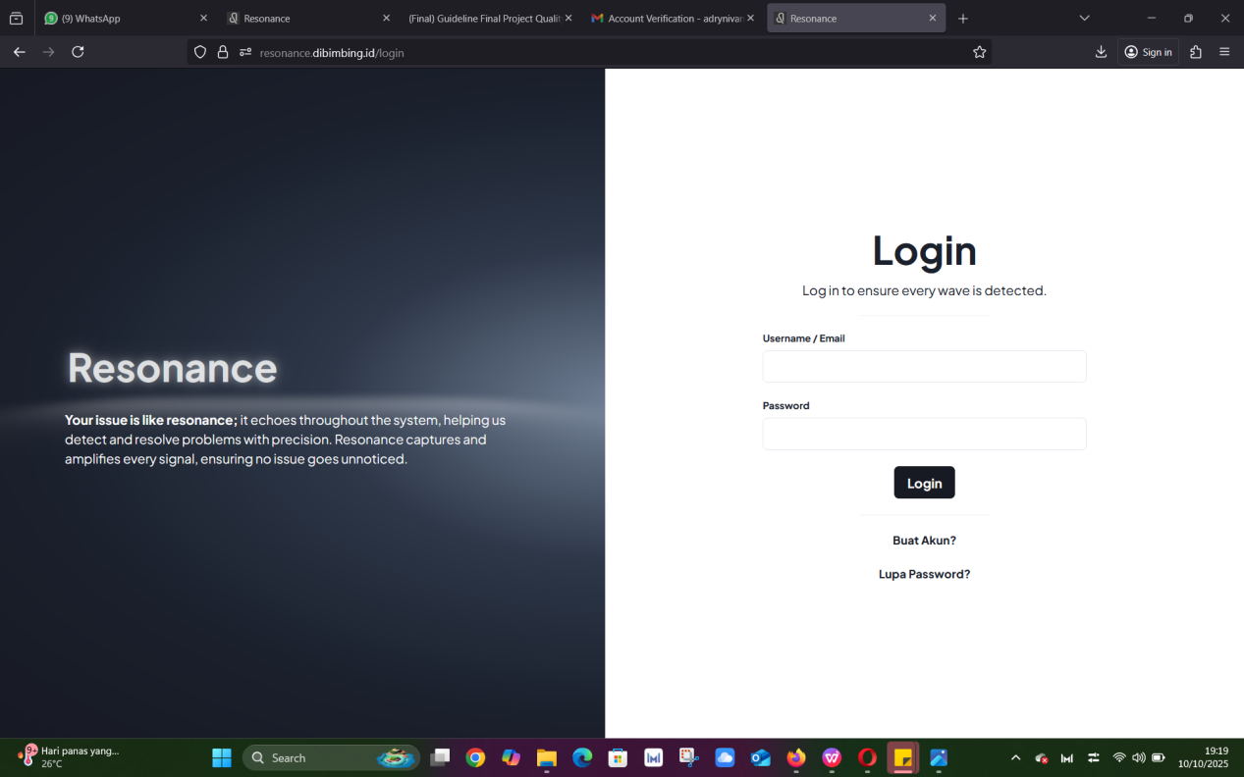

EXPECTED RESULT :

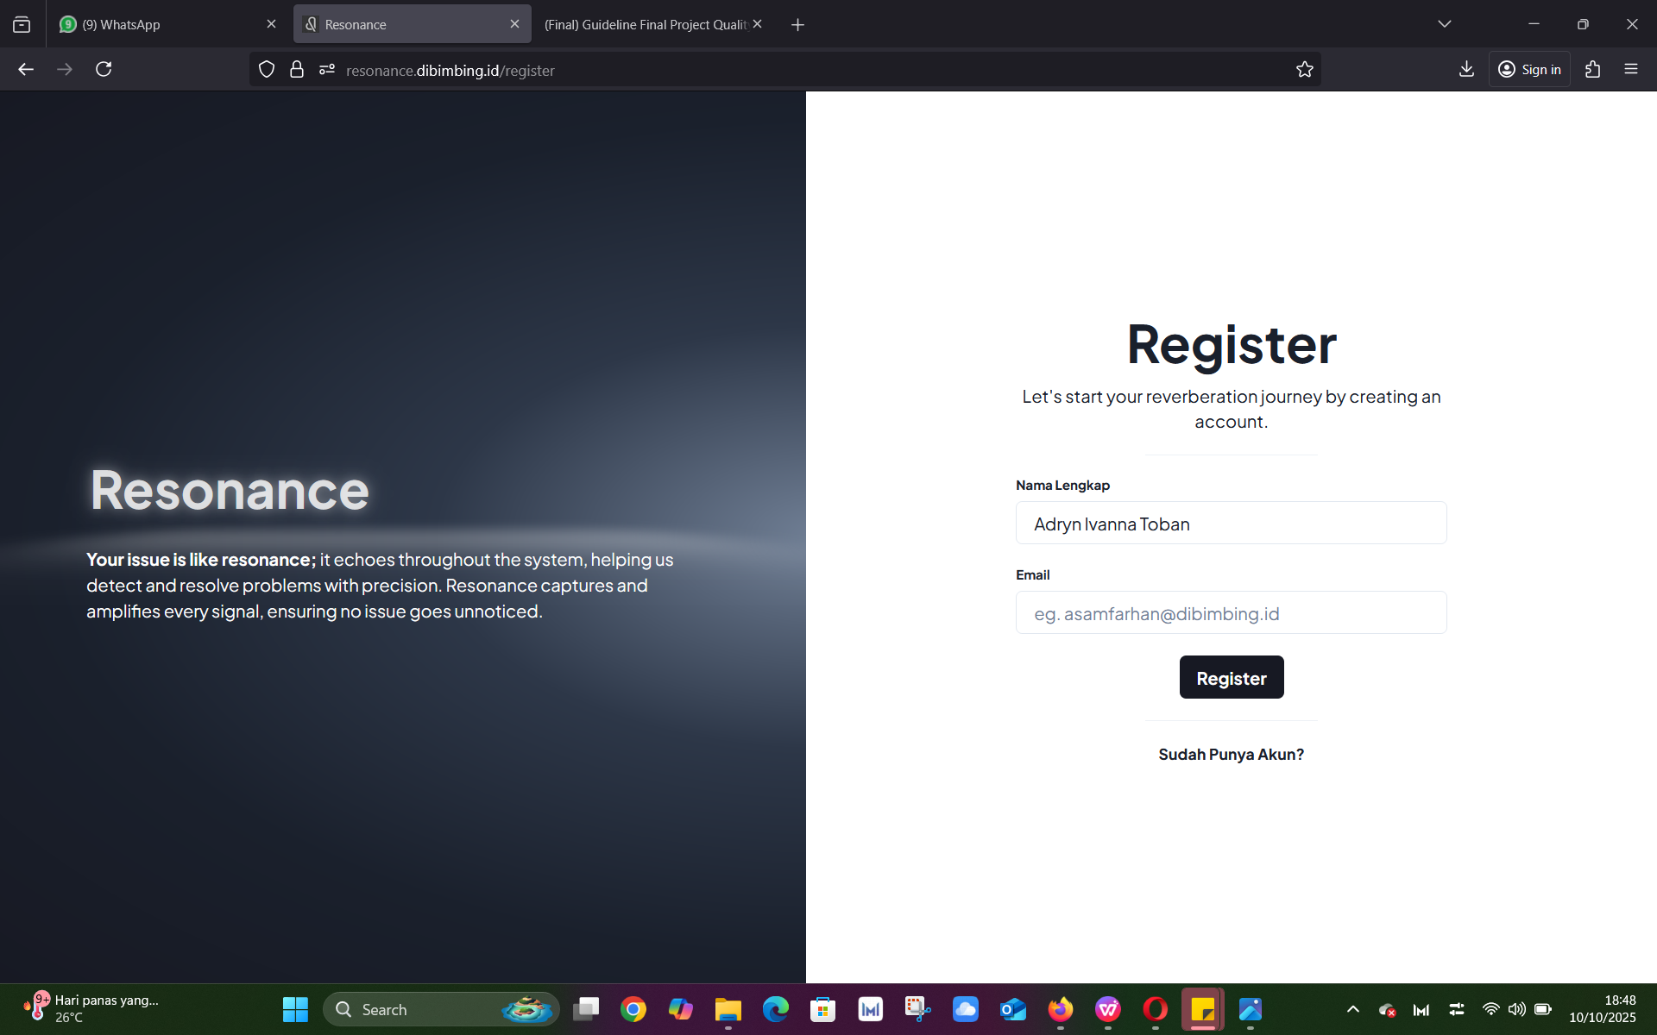

TC001-STEP 2: Input Email



EXPECTED RESULT:

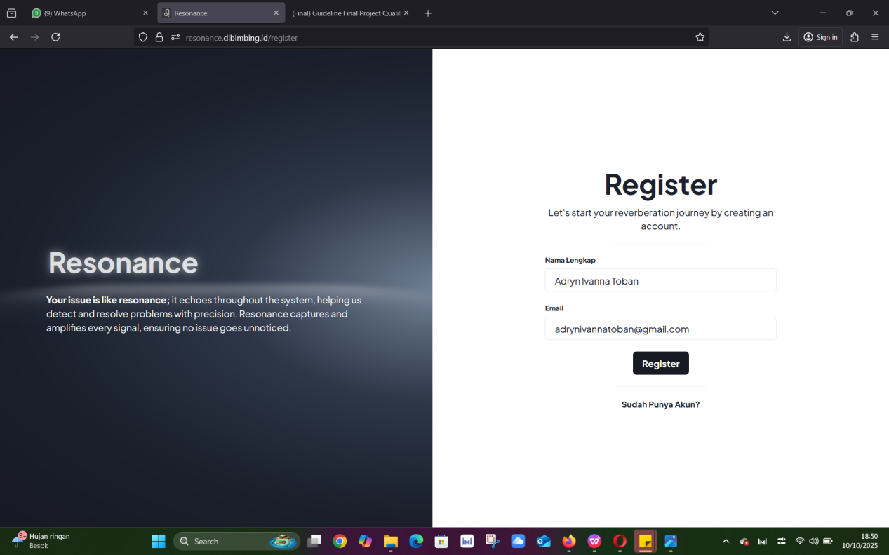

TC001 EXPECTED RESULT - STEP 3: Klik Register, maka akan muncul pesan notifikasi dalam website “Berhasil Membuat User, Email verifikasi akan dikirim”

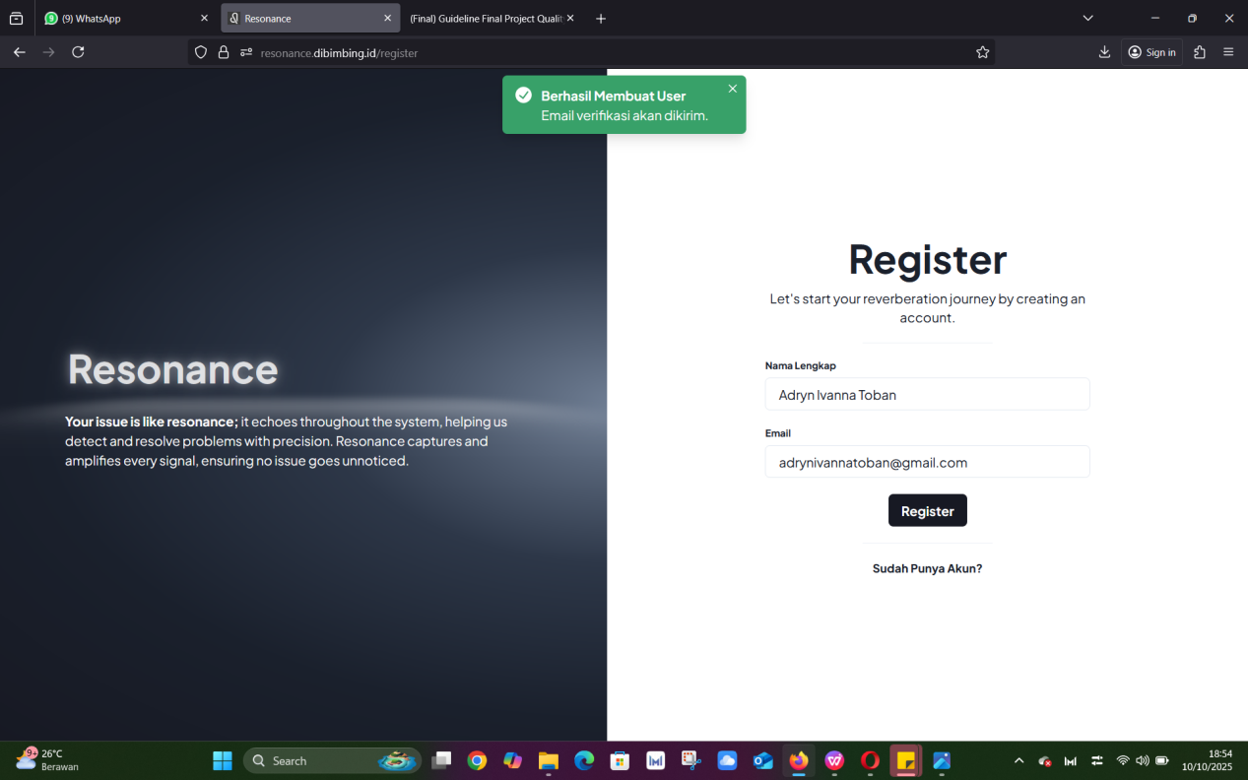

TC001 EXPECTED RESULT - STEP 4: Input Password

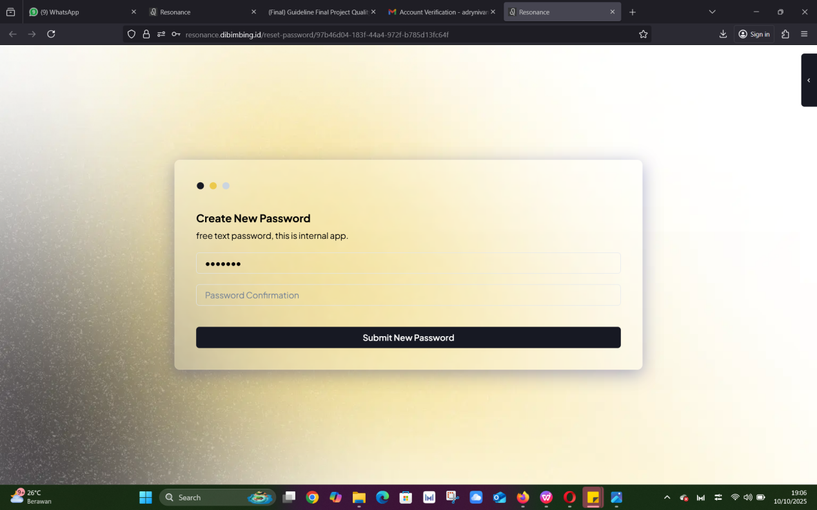

TC001 EXPECTED RESULT - STEP 5: Input Password Confirmation

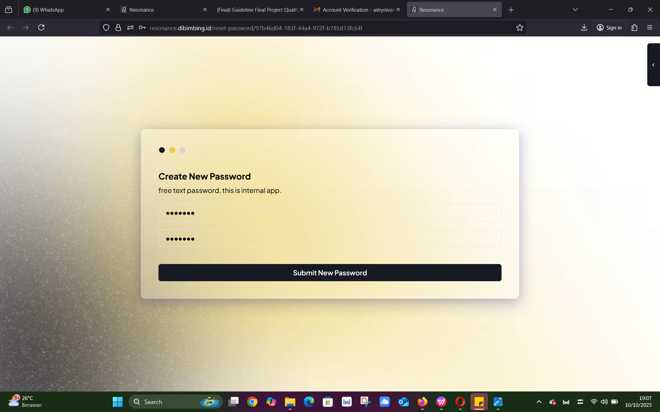

TC001-STEP 6: Klik Submit New Password



EXPECTED RESULT:

